Experiment No. 6

**BASE PYTHON FOR SCIENTIFIC COMPUTING**

Programming Assignment Screenshots

**PROBLEM 1:**

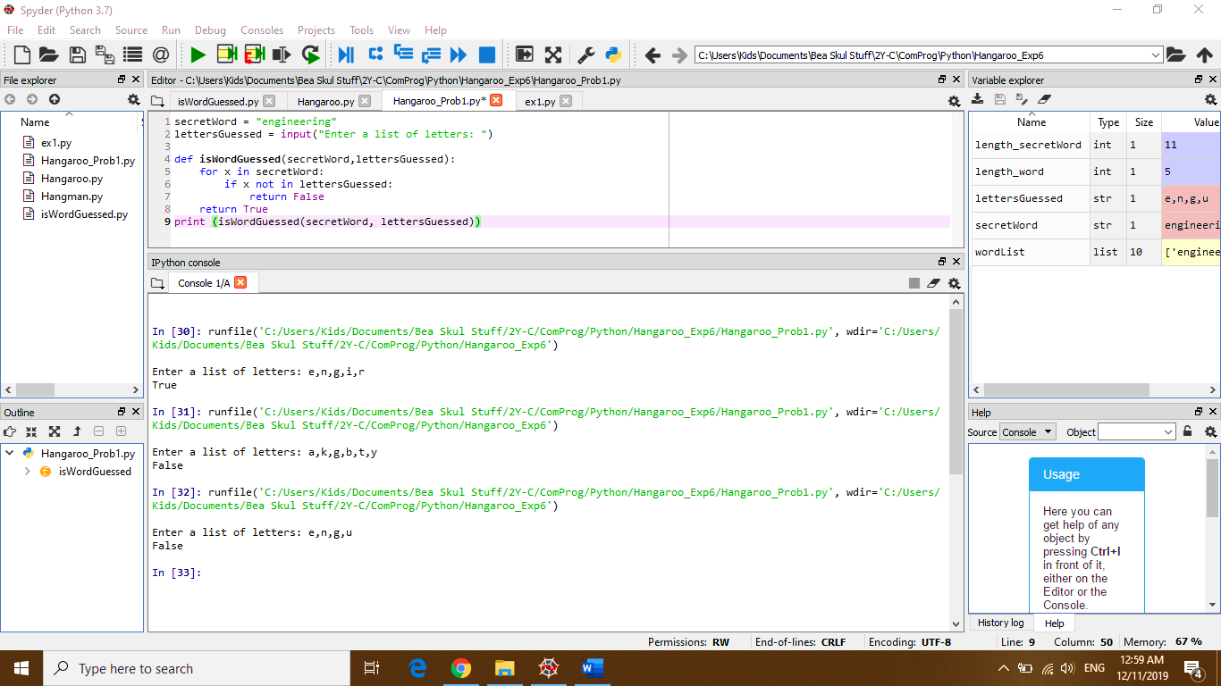

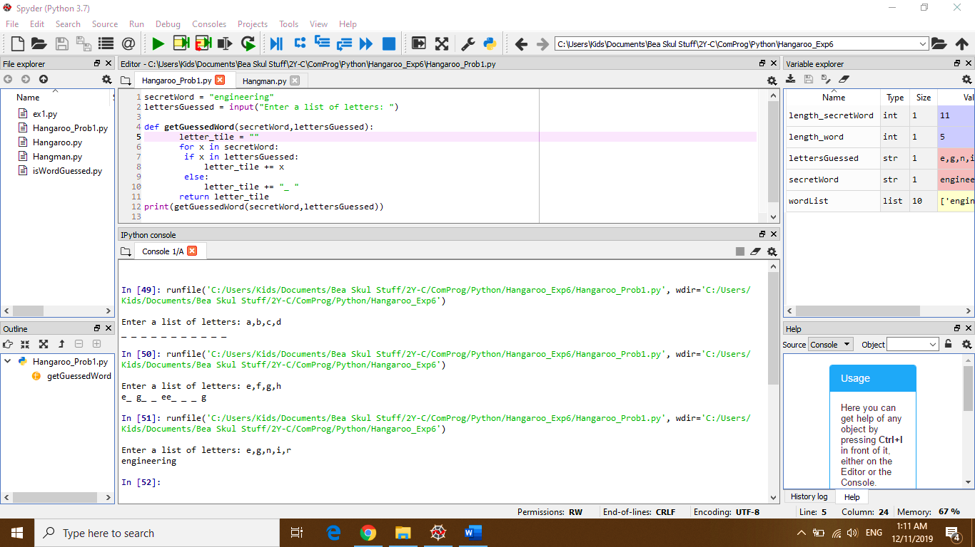**PROBLEM 2:**

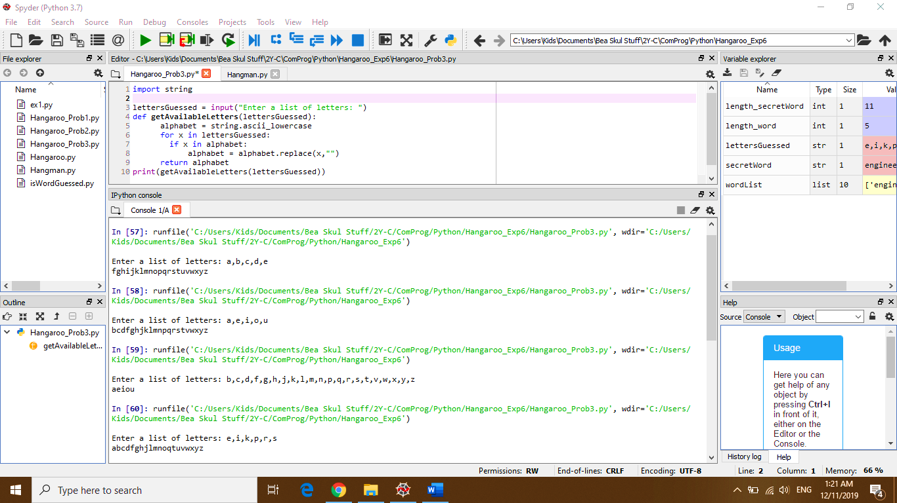**PROBLEM 3:**

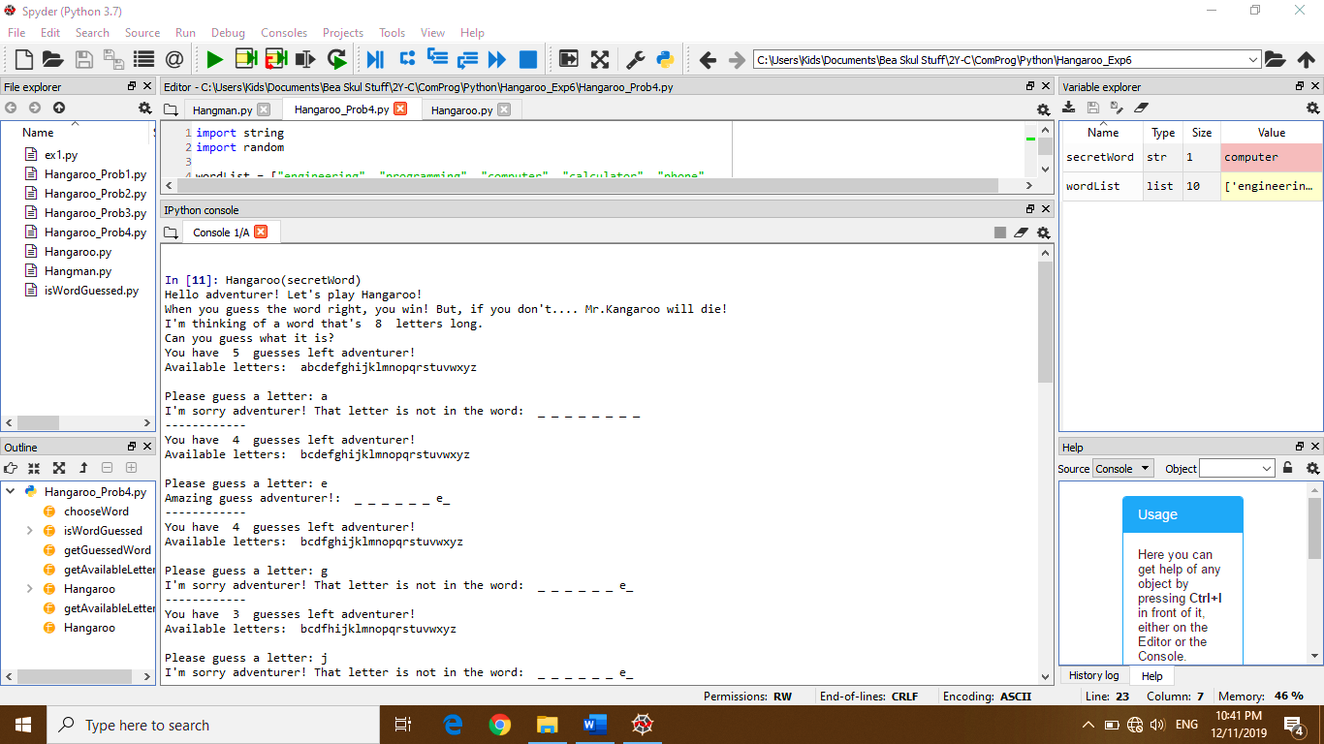**PROBLEM 4: (Failed Attempt)**

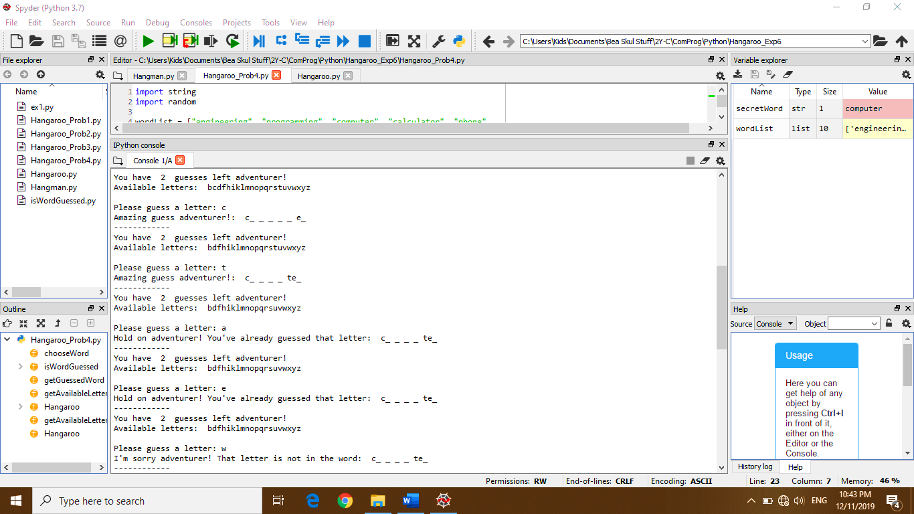

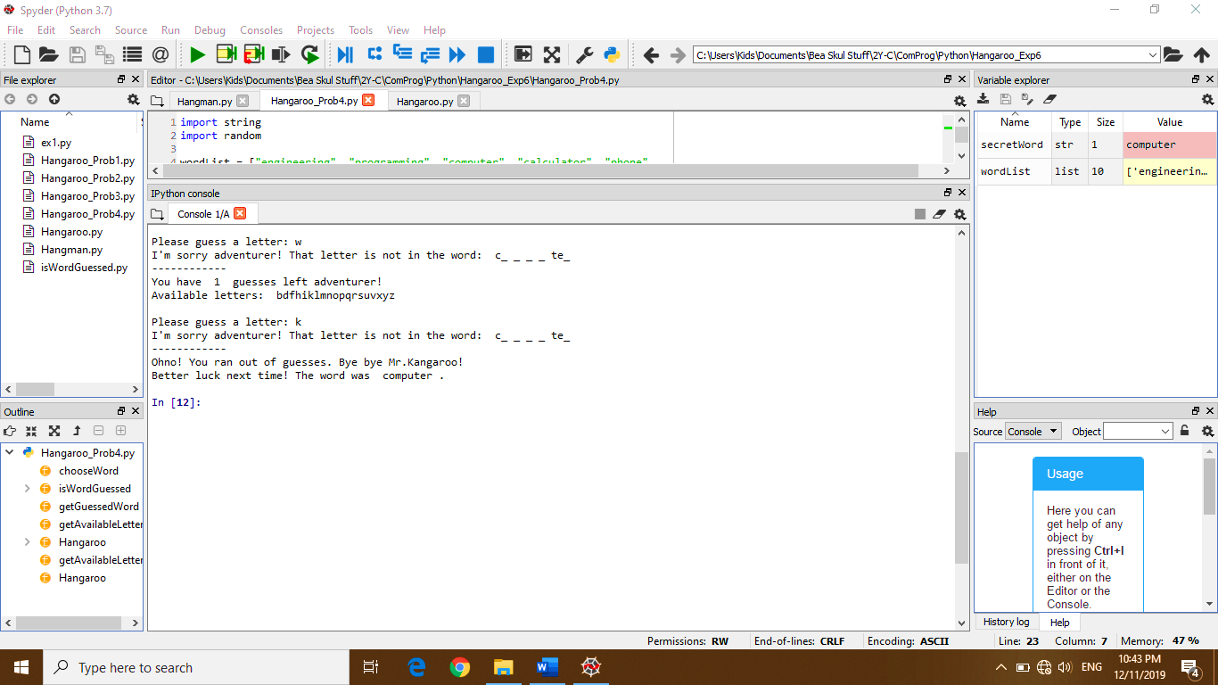

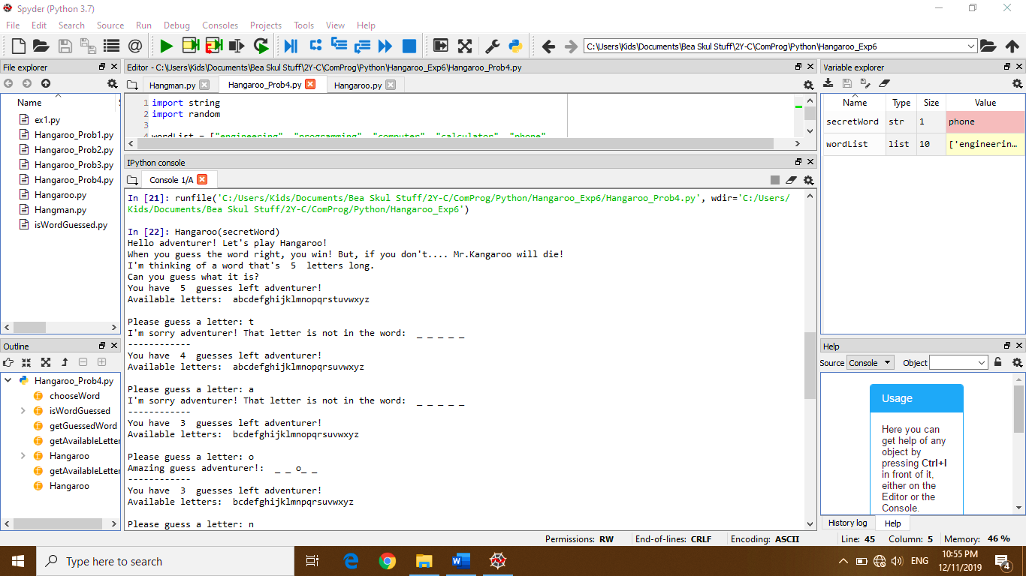**PROBLEM 4: (SUCCESFUL ATTEMPT)**

